<Behavior Extraction and Analysis Tool>
Software Design Document
<1.0>
<10/15/19>
Document Control
Approval
The Guidance Team and the customer shall approve this document.
Document Change Control
Initial Release: | 1.0
Current Release: | 1.0
Indicator of Last Page in Document: | $
Date of Last Review: | 10/15/19
Date of Next Review: | 10/15/19
Target Date for Next Update: | 10/16/19
Distribution List
This following list of people shall receive a copy of this document every time a new version of this document becomes available:
Guidance Team Members:
Dr. Gates
Dr. Salamah
Dr. Roach
Elsa Tai Ramirez
Jake Lasley
Customer:
Dr. Jaime C. Acosta
Dr. Oscar A. Perez
Vincent Fonseca
Florencia Larsen
Jesus Martinez
Baltazar Santella
Juan Ulloa
Herandy Denisse Vazquez
Software Team Members:
Daniel Almeraz
Lance Glaese
George Juarez
Hao Moy
Manuel Munoz
Alexander Wieczkowski

Change Summary
The following table details changes made between versions of this document

Version | Date | Modifier | Description
1.0 | 10/15/19 | Daniel Almeraz, Lance Glaese, George Juarez, Hao Moy, Manuel Munoz, and Alexander Wieczkowski | Creation and finalization for first draft of Document.

Table of Contents
Document Control ii
Approval ii
Document Change Control ii
Distribution List ii
Change Summary ii
1. Introduction 1
1.1. Purpose and Intended Audience 1
1.2. Scope of Product 1
1.2.1 Database 1
1.3. References 1
1.4. Definitions, Acronyms, and Abbreviations 1
1.4.1. Definitions 1
1.4.2. Acronyms 1
1.4.3. Abbreviations 1
1.5. Overview 2
2. Decomposition Description 3
2.1. System Collaboration Diagram 3
2.2. Subsystem and Component Descriptions 6
2.3. Dependencies 7
3. Detailed Description of Component <name> 8
3.1. Component Description 8
3.2. Class Description <class 1 name> 8
3.2.1. Contract <contract 1 name> 8
3.2.2. Contract <contract 2 name> 9
3.3. Class Description <class 2 name> 9
3.3.1. Contract <contract 1 name> 9
4. Database 10
4.1. Database Schema 10

Introduction

Purpose and Intended Audience
The purpose of creating the software design document is to identify the components for the system along with their subcomponents. This will allow us to better define the architecture to develop BEAT by focusing on the subsystems. The intended audience of this document are the Guidance Team Members who are both defined in Section II.

Scope of Product
The development and Engineering Command recognize the complexity and the time it takes to perform binary analysis. They want a system that would allow their analysis to reduce the amount of time required to perform a more targeted type of binary analysis via a graphical user interface.

The University of Texas at El Paso (UTEP) and Development and Engineering Command are collaborating to develop a Behavior Extraction and Analysis Tool (BEAT) that will provide the ability to conduct binary analysis intercept and the ability to modify contents of network packets via a graphical user interface.

1.2.1 Database
The goal of the database is to store and retrieve Point of Interest attribute values that were generated during static and dynamic analysis.

References
[1] D. Almeraz, L. Glaese, G. Juarez, H. Moy, M. Munoz, and A. Wieczkowski, “Team 1 Clients Overview of Prototype.” El Paso, 09-Oct-2019.

[2] A. Gates, S. Salamah, S. Roach, and E. T. Ramirez, “Behavior Extraction and Analysis Tool Software Requirements, Specification.” El Paso, 28-Aug-2019

Definitions, Acronyms, and Abbreviations

Definitions
Comment | A written remark made on a point of interest.
Static Analysis Data Set | A set of filtered points of interest.
Dynamic Analysis Data Set | A set of filtered points of interest with values from the execution of a binary file.

Acronyms
SRS | Software Requirements Specification
UTEP | University of Texas at El Paso
BEAT | Behavior Analysis and Extraction Tool

Abbreviations
e.g. | For example
i.e. | That is
TBD | To be determined

Overview
This document will contain Decomposition Description in Section 2, Detailed Description of Component in Section 3, and Database in Section 4. Section 2 will contain the System Collaboration Diagrams in Section 2.1, Subsystems and Component Descriptions in Section 2.2, and Dependencies in Section 2.3. Section 3 will contain Component Description in Section 3.1, Class Description Analysis in Section 3.2, Class Description Points of interest in Section 3.3, Class Description Plugin Manager in Section 3.4, Class Description Radare in Section 3.5, and Class Description of XML Schema in Section 3.6. Section 4 will contain the Database Schema in Section 4.1.

Decomposition Description
Our component descriptions can be used by designers and maintainers to identify in which subsystem they can expect to find the corresponding information. This way the designers will be able to easily add new major design entities to collaborate in cohesive units. Also, they will be able to provide the proper functions to the expected subsystems. The maintainers will be able to determine which subsystem is responsible for a specific function by proper naming conventions and cohesion. Also, they will be able to easily trace the requirements to design entities.

System Collaboration Diagram
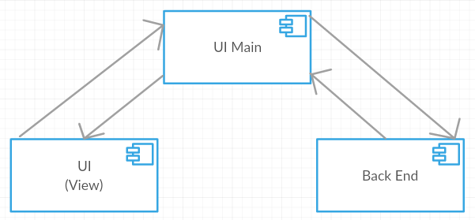
Figure 1: MVC

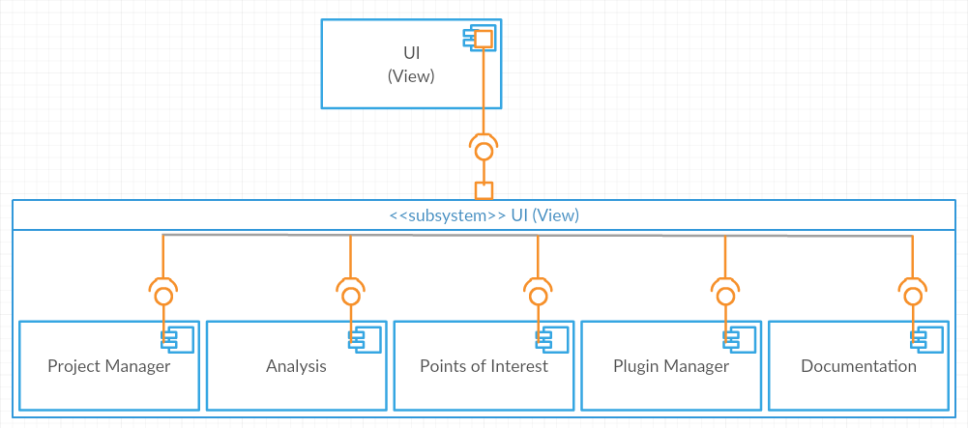
Figure 2: UI (View)
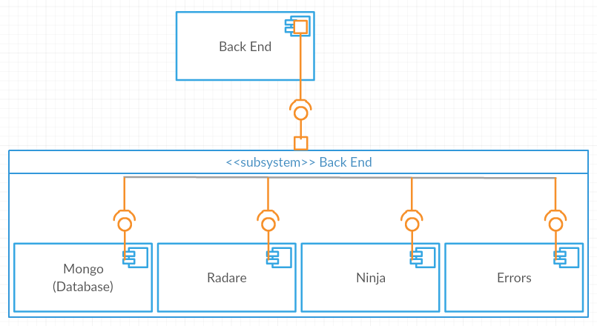
Figure 3: Back End
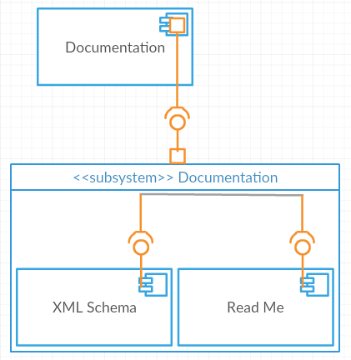
Figure 4: Documentation
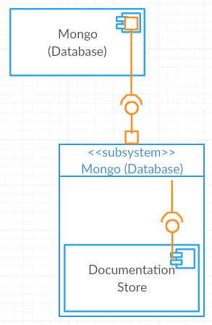
Figure 5: Mongo (Database)

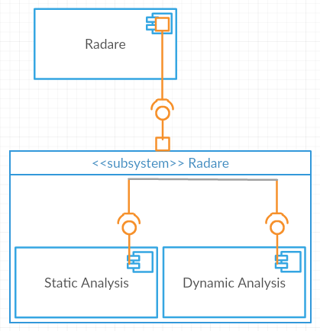
Figure 6: Radare
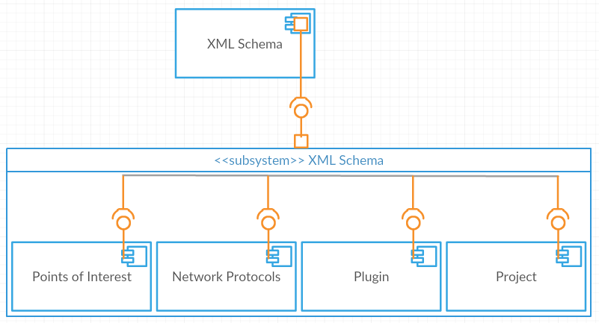
Figure 7: XML Schema

Our Version of BEAT can be represented as a modified MVC Model where the View and Model do not communicate with each other. The UI (View) contains five windows in which the user can interact with the Back End (Model) to provide greater functionality to Radare. The Back End communicates with Mongo (Database), Radare, and Ninja to perform binary analysis and the errors will handle improper use of BEAT. The Documentation component contains two types of documentation the XML Schemas which provides the structure of Points of Interest, Network Protocols, Plugin, and Project and the readme file and stored in Mongo (Database). The Radare component contains the classes Find POI, Hello, List Imports, Radare Commands Interface.

Subsystem and Component Descriptions
<< Provide a description of subsystems and components in the diagrams in section 2.1. For each component or subsystem to be described in this document, give the name, describe the purpose, and list the contracts supported by this component (e.g., the subsystem contracts). Indicate where in the following detailed sections of this document each component is discussed. >>
Component Name: UI Main
Component Purpose: This component will act as the Controller for the user to select which component of the UI (View) they wish to interact with.
Component Contract List: N/A
Component Name: UI (View)
Component Purpose: This component will act as the View to provide an interface for the user to interact with.
Component Contract List: Program Manager
Analysis
Points of Interest
Plugin Manager
Documentation
Component Name: Back End
Component Purpose: This component will act as the Model which will provide how all functionality works which is non-important to the user.
Component Contract List: Mongo (Database)
Radare
Ninja
Errors
Component Name: Documentation
Component Purpose: This component allows the client to be able to view any xml file currently used in the loaded project.
Component Contract List: Readme File
XML Files
Component Name: Mongo (Database)
Component Purpose: This component stores any xml file that has been loaded in the past.
Component Contract List: Documentation Store
Component Name: Radare
Component Purpose: This component plugs into BEAT and provides points of interest from analysis to be filtered.
Component Contract List: Static Analysis
Dynamic Analysis

Dependencies
The components dependencies will impact development by allowing us to make sure current components are cohesive and most importantly where components are currently being coupled and how tightly and the current hierarchy used. The identification process will help us to see where our system is currently and how to improve it. Once these dependencies are understood we will be able to provide documentation of the current subsystems the project is using. By locating the subsystems, we will be able provide better maintenance since we are considering this while implementing the system. This will make a better software for the clients to both understand and further develop the system we are to develop.

Detailed Description of Component <name>

Component Description

Component Name: Analysis
Component Purpose: This component allows the client to perform static and dynamic analysis by Radare offering the functionality features desired by our clients.
Component Class List: Output Field View
Comment View
Analysis Result View
Terminal

Component Name: Points of Interest
Component Purpose: This component allows the client to see the desired network data of a specified type.
Component Class List: Functions
Strings
Variables

Component Name: Plugin Manager
Component Purpose: This component allows the client to see the list of imported plugins.
Component Class List: Imports

Component Name: Radare
Component Purpose: This component plugs into BEAT and provides points of interest from analysis to be filtered.
Component Class List: Find POI
Hello
List Imports
Radare Commands Interface

Component Name: XML Schema
Component Purpose: This component provides XML Schemas for types of desired data.
Component Class List: Points of Interest
Network Protocols
Plugin
Project

Class Description Analysis
Class Name: Output Field View
Class Description: This class will display the output of the output file.
Super Class: Analysis
Class Private Responsibilities: Retrieves the Output file from the Database.

Class Name: Comment View
Class Description: This class contains all comments left by the user.
Super Class: Analysis
Class Private Responsibilities: N/A

Class Name: Analysis Results View
Class Description: This class will provide the user with processed binary analysis.
Super Class: Analysis
Class Private Responsibilities: N/A

Class Name: Terminal
Class Description: This class allows the user input arguments via command line.
Super Class: Analysis
Class Private Responsibilities: N/A

Contract Output Field View
Contract Identifier: Output Field View
Contract Name: Database Retrieval
Contact Description: The Output Field View from Analysis will communication the Database component to retrieve the Output File.
Contract Protocols: Responsibilities: N/A
Method Signature: N/A
Pre-Conditions: N/A
Post-Conditions: N/A
Algorithm Description: N/A
Algorithm Collaboration: Database communicates with the UI Main Component to fetch appropriate files.

Contract Comment View

Contract Analysis Result View

Contract Terminal

Class Description Points of Interest
Class Name: Functions
Class Description: This class provides information on how to identify a Function data types.
Super Class: Points of Interest
Class Private Responsibilities: N/A

Class Name: Strings
Class Description: This class provides information on how to identify a String data types.
Super Class: Points of Interest
Class Private Responsibilities: N/A

Class Name: Variables
Class Description: This class provides information on how to identify multiple Variable Data Types.
Super Class: Points of Interest
Class Private Responsibilities: N/A

Contract Functions

Contract Strings

Contract Variables

Class Description Plugin Manager
Class Name: Imports
Class Description: This class allows the client to see the list of imported plugins.
Super Class: Plugin Manager
Class Private Responsibilities: N/A

Contract Imports

Class Description Radare
Class Name: Find POI
Class Description: Allows the user to find a Point of Interest.
Super Class: Radare
Class Private Responsibilities: N/A

Class Name: Hello
Class Description: A test file to perform Binary Analysis on.
Super Class: Radare
Class Private Responsibilities: N/A

Class Name: List Imports
Class Description: A list of imports currently connected to Radare.
Super Class: Radare
Class Private Responsibilities: N/A

Class Name: Radare Commands Interface
Class Description: The terminal is used from BEAT to perform binary analysis.
Super Class: Radare
Class Private Responsibilities: N/A

Contract Find POI

Contract Hello

Contract List Imports

Contract Radare Commands Interface

Class Description XML Schema
Class Name: Points of Interest
Class Description: The structure of a type of Point of Interest.
Super Class: XML Schema
Class Private Responsibilities: N/A

Class Name: Network Protocol
Class Description: The structure of identified network protocols.
Super Class: XML Schema
Class Private Responsibilities: N/A

Class Name: Plugin
Class Description: The structure of a type of Plugin.
Super Class: XML Schema
Class Private Responsibilities: N/A

Class Name: Project
Class Description: The structure of the Project.
Super Class: XML Schema
Class Private Responsibilities: N/A

Contract Points of Interest

Contract Network Plugin

Contract Plugin

Contract Project

Database

Database Schema
<DATABASE> Project
<COLLECTION> Point of Interest
<DOCUMENT> Point of Interest Attributes
</DOCUMENT>
</COLLECTION>
</DATABASE>

$

